INDOOR LOCALIZATION SYSTEM USING BEACONS

SYSTEM DESIGN

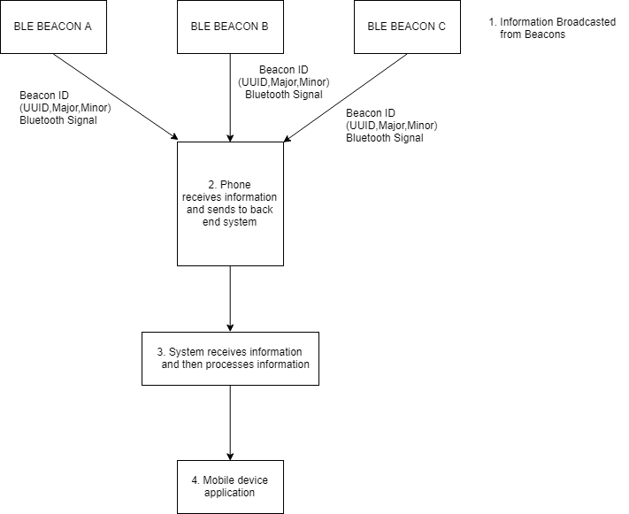

ARCHITECTURAL DIAGRAM

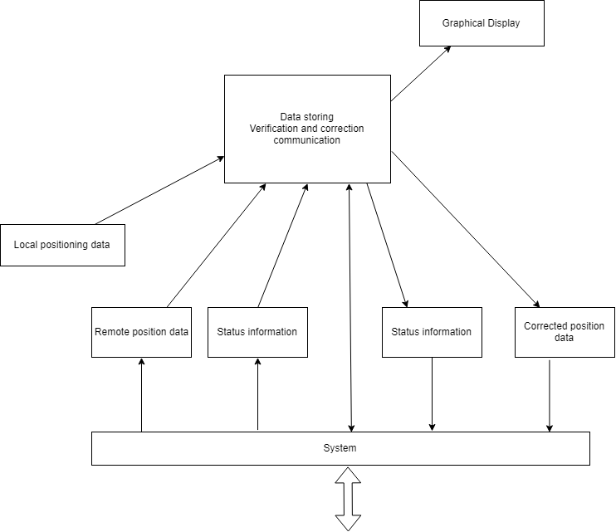

The overall system consists of 3 roles: Mobile App, iBeacon. The

3 roles are elaborated as follows:

**Mobile App:** A locating application running on mobile users’

smartphones. It listens to the beacon messages sent by the Beacons

to figure out the current location of the mobile user.

**iBeacon:** A beacon device that can send, receive, and relay

messages in the Bluetooth beacon network. Specifically, it not only

broadcasts beacon messages. The message format of

iBeacon consist of 4 fields: UUID, Major, Minor, and TX power. By

comparing the received signal strength of the iBeacon message, the

receiver can determine the approximate proximity to the iBeacon

transmitter.

**Beacon Scan:** By using FastBleLib:2.3.2 Library we scan for beacons.

When a Bluetooth scanner receives an advertising packet, it decodes

the content and takes corresponding actions.

**Flow of Operations**

In this subsection we describe the flow of operations of our system. When the IBeacons are powered on, they periodically broadcast beacon in the following, we illustrate the flow of operations when a smartphone user with our Mobile App enters the communication range of us Bluetooth beacon network.

When the Mobile App discovers a beacon message from a certain Beacon, it extracts the beacons rssi, txpower, major, minor, mac, address using fastble library. When it scans three beacons it uses triangulation to get the location of user.

**Triangulation:**

